AUTO TICKET CLASSIFICATION USING FLOW DESIGNER
PHASE 7 – PROJECT DOCUMENTATION
ServiceNow • Flow Designer • School IT Helpdesk

Purpose – To provide a clear, reusable record of the completed Auto Ticket Classification using Flow Designer project, including its problem statement, objective, implementation summary, testing outcome, deployment/update-set procedure, and conclusion.

7.1 Project Overview
The school IT helpdesk receives multiple incident requests from students and teachers, including Wi-Fi issues, projector failures, password problems, and slow computers. The project automates ticket classification using ServiceNow Flow Designer by analyzing keywords in the incident Short Description and Description fields.

7.2 Project Objectives
- Automatically classify incidents at the time of creation.
- Reduce manual effort for IT agents.
- Improve ticket routing efficiency.
- Implement a no-code and easily maintainable solution.

7.3 Implemented Solution
- A custom Incident Workflow table stores ticket records.
- Required fields include Number, Caller, Category, Subcategory, Short Description, Description, State, Assigned Group, and Assigned to.
- Category and Subcategory are configured with dependency logic.
- Flow Designer uses keyword-based conditions to classify tickets automatically.
- An email notification is sent to the caller after ticket creation/classification.

7.4 Classification Logic
Keyword / Issue | Category | Subcategory
WiFi / Network | Network | WiFi
Projector | Hardware | Projector
Password / Login | Access | Forgot Password
Slow / Hanging | Performance | Slow Computer

7.5 Testing Evidence
The project documentation records successful test cases for Wi-Fi and projector issues, including automatic category/subcategory assignment and caller email notification.
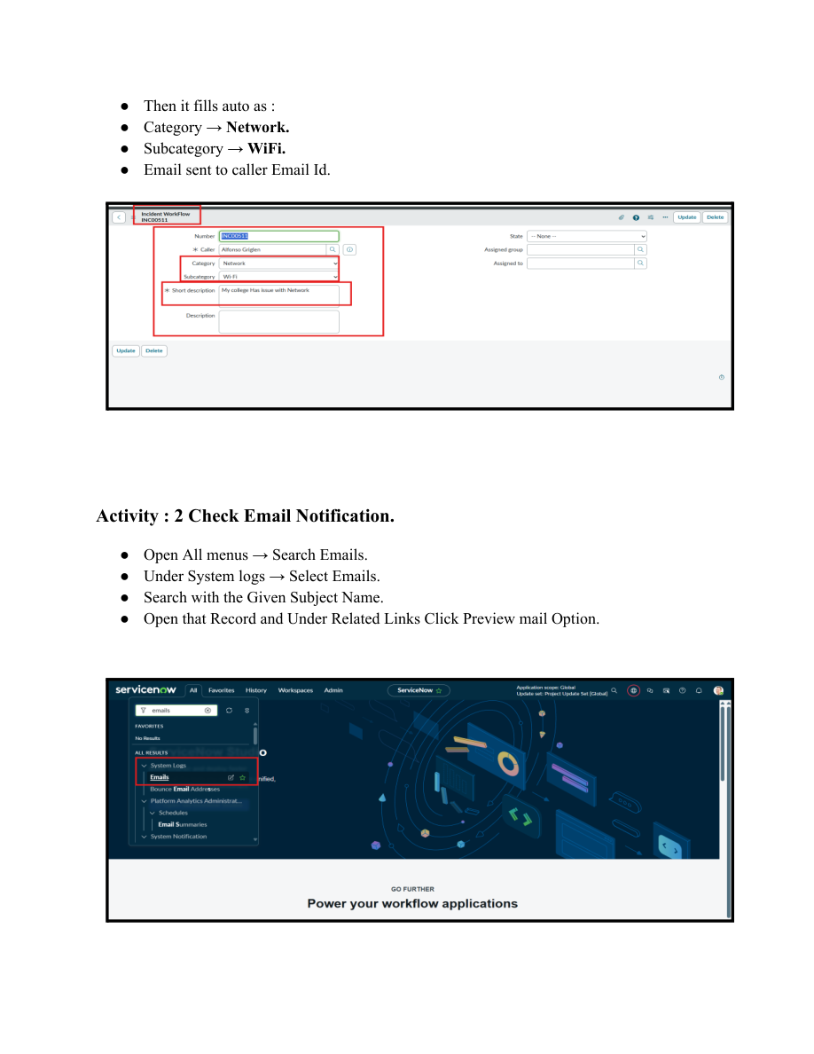
Figure 7.1 – Testing evidence from the project

7.6 Deployment / Update Set Documentation
- Open All menus → Search for Local Update Sets.
- Under System Update Sets, select Local Update Sets.
- Open the Project Update Set.
- Change State from In progress to Complete.
- Save the form.
- Under Related Links, select Export to XML.
- The Update Set data is downloaded in XML format and can be shared for transfer to another environment.

7.7 Email Notification
After classification, the Flow Designer sends an email to the Caller → Email. The configured subject is “Your Request for the issue has been submitted.” The body contains the ticket confirmation message.
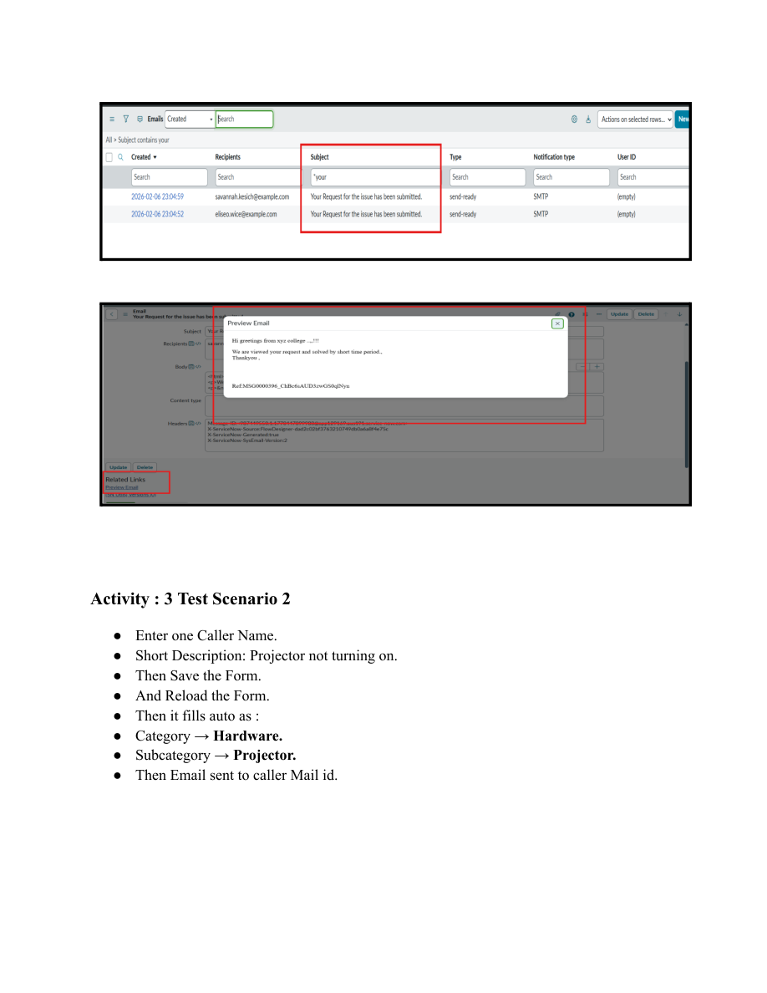
Figure 7.2 – Email notification evidence

7.8 Maintenance & Future Scope
The source documentation describes the solution as easy to maintain, scalable, and completely no-code. Future extensions identified in the project include assignment automation, SLA tracking, and predictive intelligence.

7.9 Final Conclusion
The Auto Ticket Classification using Flow Designer project provides an end-to-end automation solution for a school IT helpdesk. It reduces manual categorization effort, improves ticket routing, uses dependent choice fields for data consistency, and provides immediate email acknowledgement. The phased implementation supports clarity, stability, and maintainability, while the testing and validation activities confirm reliable operation for the documented scenarios.

7.10 Project Reference Evidence
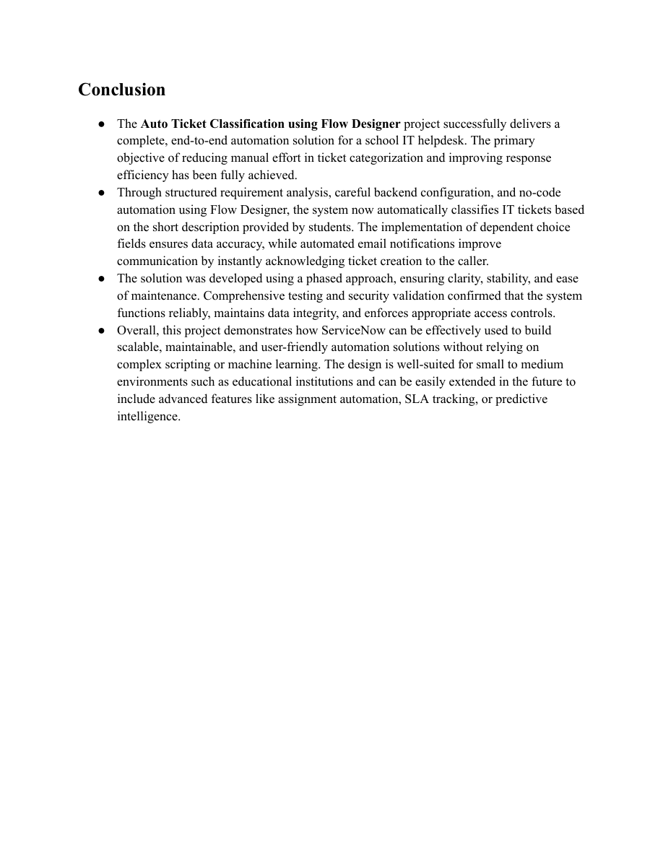
Figure 7.3 – Project conclusion/reference page from the supplied documentation

